**WIKI REPORT ICP-10**

**A)**I have learned how to design a Deep Q learning Network (DQN), using Keras & OpenAI Gym,for cartpole game and visualizing results.

**B)**Main task is to design a Deep Q learning Network (DQN), using Keras & OpenAI Gym,for cartpole game and visualizing results.

CartPole’s goal is to balance a pole connected with one joint on the top of a moving cart.



To perform this task i have used 2 tools like:

* [OpenAI Gym](https://gym.openai.com/): It provides a simple interface for interacting with the environment of a lot of old video games. They have also got a good collection of Atari games.OpenAI Gym is a game simulator. Therefore, it provides us with usable variables (the State, angle of the pole, position of the cart, …) instead of providing pixel information.
* [Keras](https://keras.io/): which is capable of running on top of the Deep Learning library.

Imported all the required libraries like gym, numpy as np, matplotlib.pyplot as plt, from collections import deque, tensorflow as tf, tensorflow import keras, random, from gym import wrappers .

Then created Gym environment using **envCartPolegym.make('CartPole-v1')**

Then Setted the seed to keep the environment consistent across runs using **envCartPole.seed(50).**

Then performed Vectorization to run episodes faster. Most of these vectorizations will be calling a method versus just adding 10 but this is a simple solution. You will see a TREMENDOUS speed up avoiding the loops in python.

[CartPole](https://gym.openai.com/envs/CartPole-v1/) environment from OpenAI.

The actions are 0 to push the cart to the left and 1 to push the cart to the right.

The continuous state space is an X coordinate for location, the velocity of the cart, the angle of the pole, and the velocity at the tip of the pole. The X coordinate goes from -4.8 to +4.8, velocity is -Inf to +Inf, angle of the pole goes from -24 degrees to +24 degrees, tip velocity is -Inf to +Inf. With all of the possible combinations we can see why we can't create a Q table for each one.

To "solve" this puzzle I have to have an average reward of > 195 over 100 consecutive episodes. One thing to note, I am hard-capping the rewards at 210 so this number can't average above that and it also could potentially drive the average down.

Created Global variable, hyperparameters and class named **DeepQNetwork().**

**Deep Q-Network Class:**

The following class is the deep Q-network that is built using the neural network code from Keras.

In class i have defined some function’s like

**Init**: This creates the class and sets the local parameters.I used a *deque* for the local memory to hold the experiences and a keras model for the NN.

**build_model(self)**:This builds the NN. I am using a sequential model. Each of the layers are *Dense*. I am using an input layer(4), 24 neuron layer, 24 neuron layer, and an output layer(2).For calculating the loss I used mean squared error.For an optimizer I used [Adam](https://arxiv.org/abs/1412.6980v8). It is a variant of gradient descent.

**action(self,state)**:This generates the action.

Explore: I used the epsilon.

Exploit: I used the NN to grab the 2 possible actions and then grab the argmax to find the better one.

**test_action(self,state)**: This generates the action when I am testing. I want to 100% exploit.

**store(self, state, action, reward, nstate, done)**:This places the observables in memory

**experience_replay(self, batch_size)**:This is where the training occurs. I grabbed the sample batches and then used the NN to predict the optimal action.

Then created an Agent and trained the model. In Training if the done or time == 209 then i’m printing the number of episodes, score and error( As per my observations, the number of episodes increasing score is increasing and error is decreasing ). The iteration stops when the neural network passes and the rest of them are used for testing (ie.. as per my output the iteration stopped at 94 episodes out of 500 it means NN passed in the model at 94 and remained used for testing).

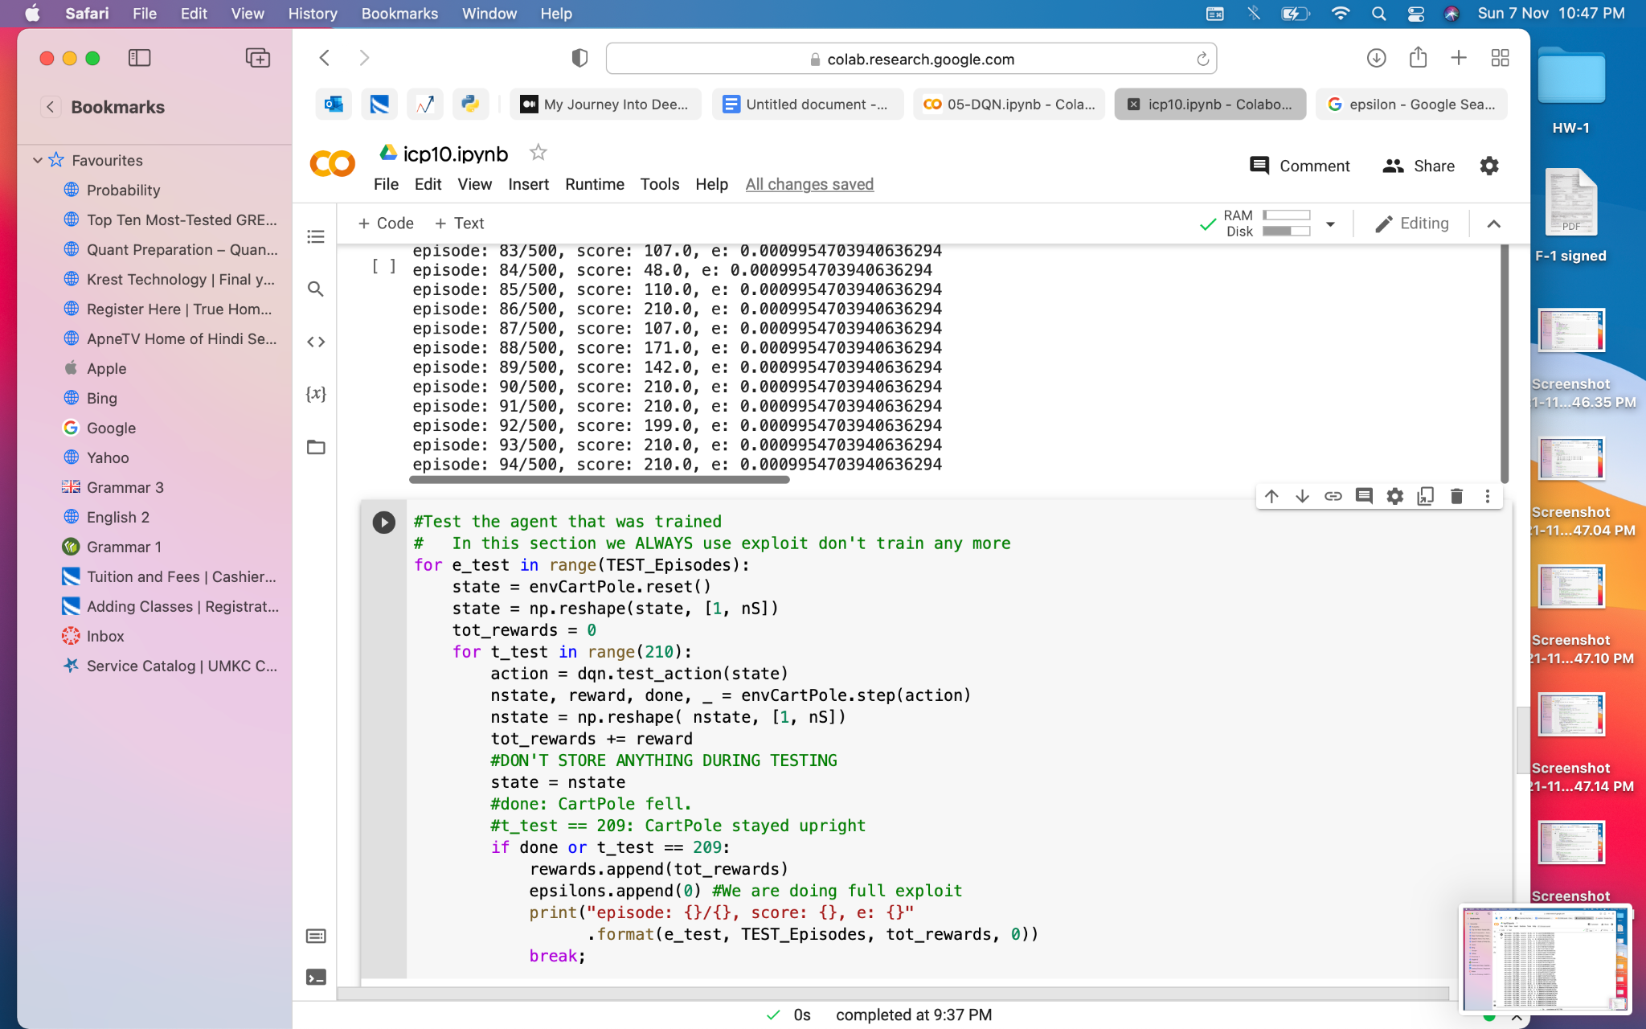

Then I tested the agent that was trained. Here I have only exploited and didn't train anymore. It trained well for every episode the score was the same and the error was zero. Then plotted a graph for better visualization.

Final Results are:

Black: This is the 100 episode rolling average.

Red: Reward line.

Blue: This is the reward for each episode.

Green: This is the value of epsilon scaled by 200.

Yellow: This is where the tests started.

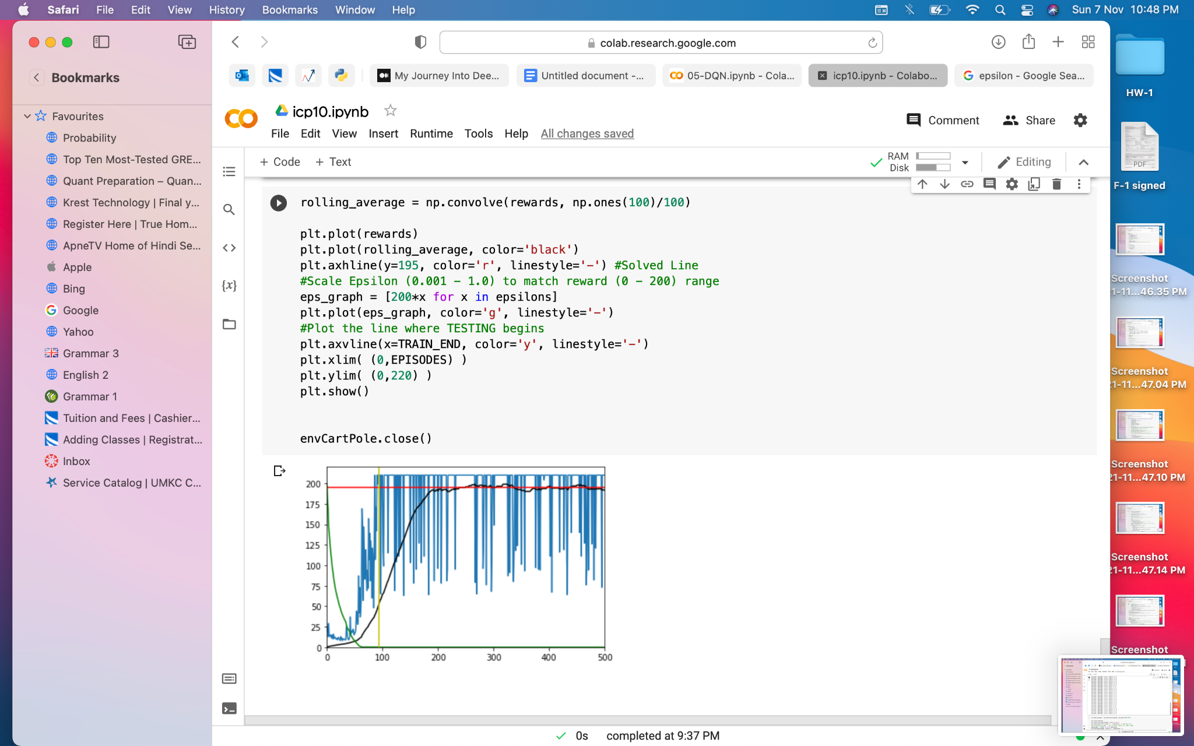

**C)**The challenges that I have faced in this icp is adding compatible layers in DQN and importing libraries.

**D)Screenshots:**

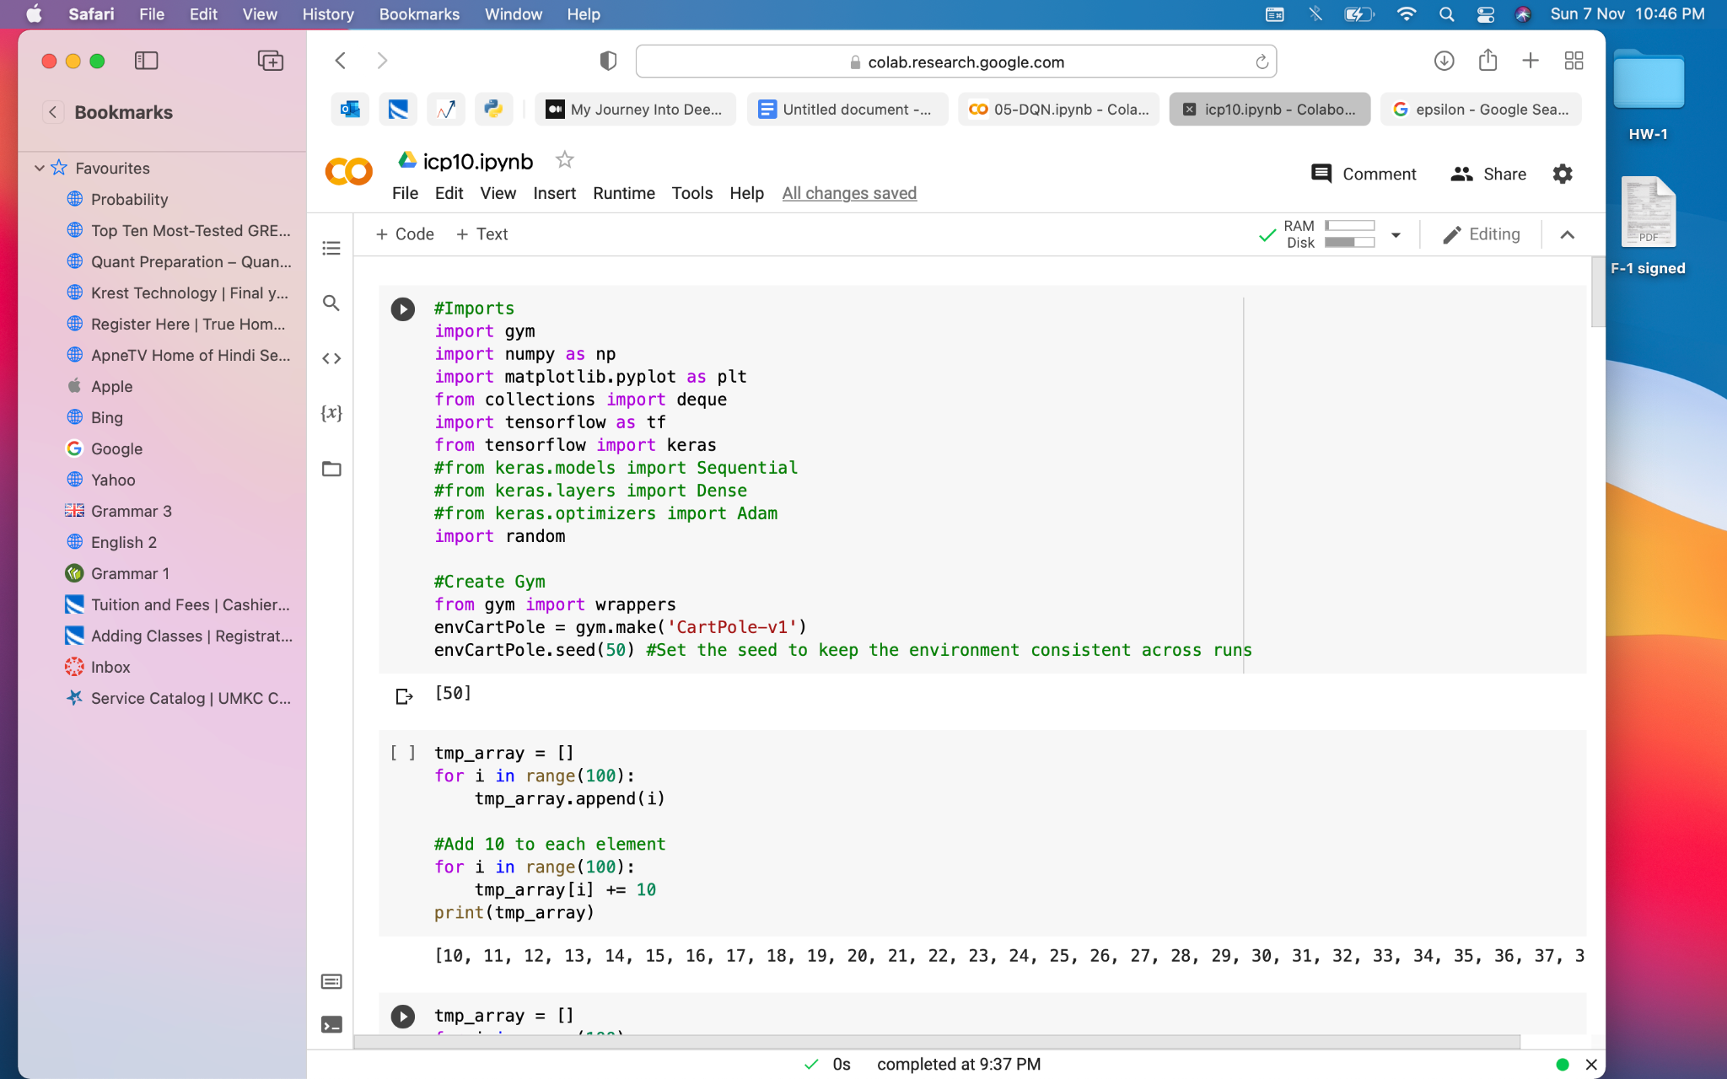

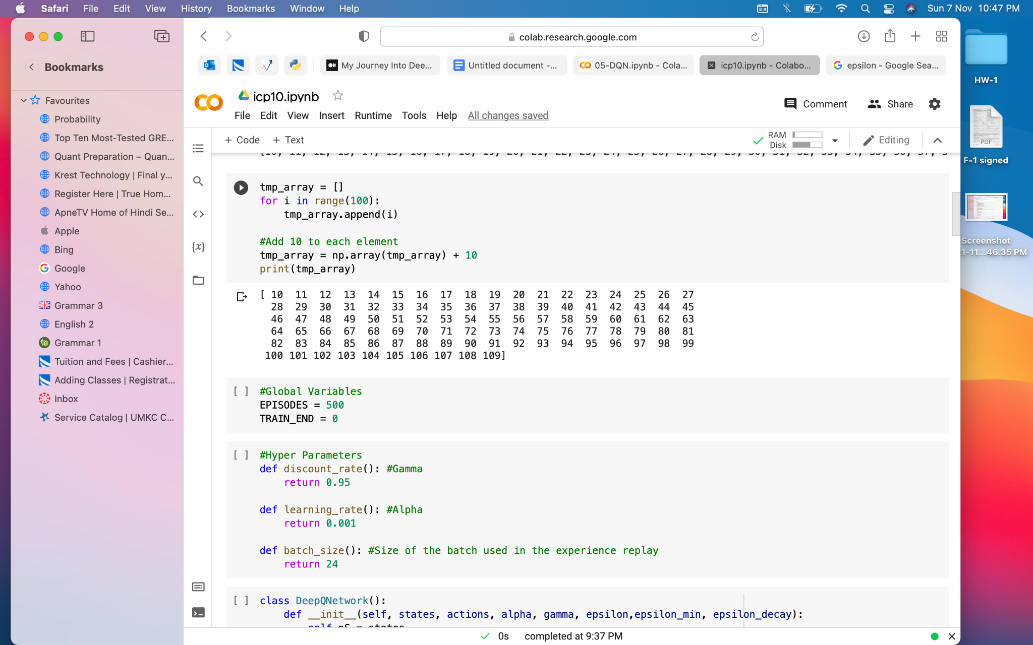

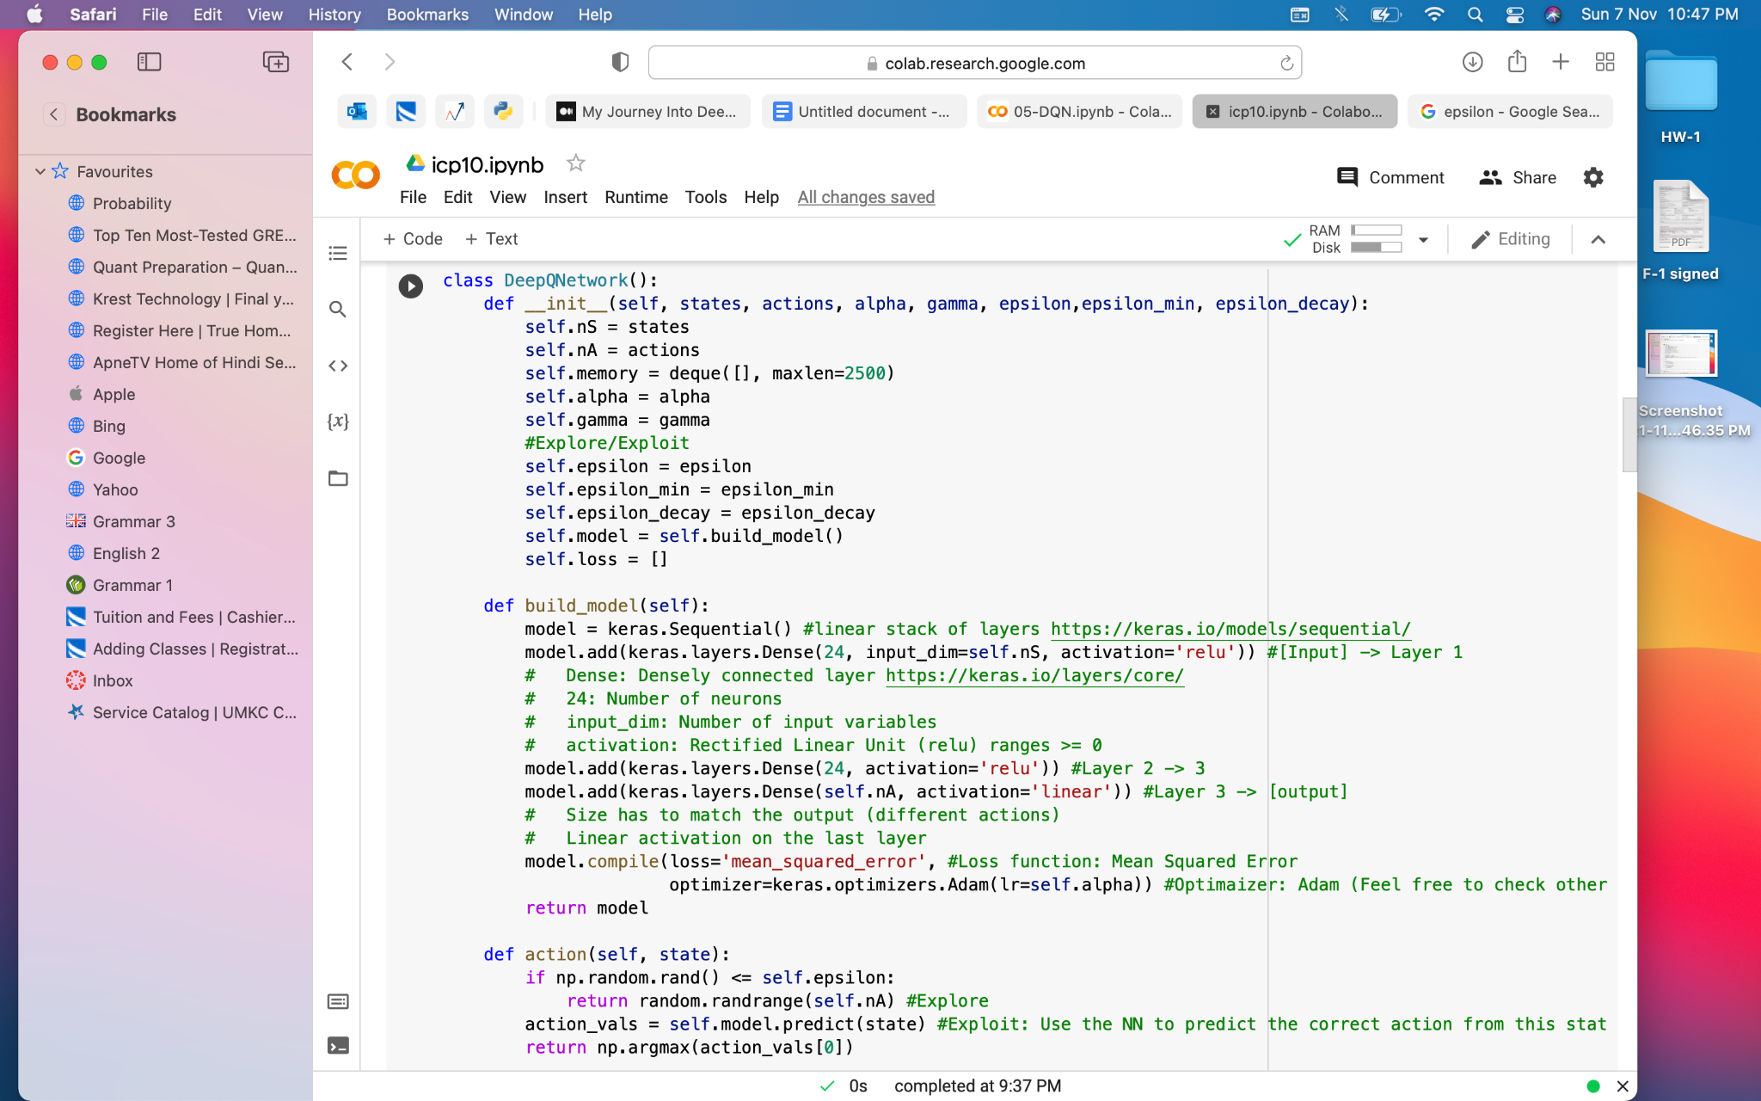

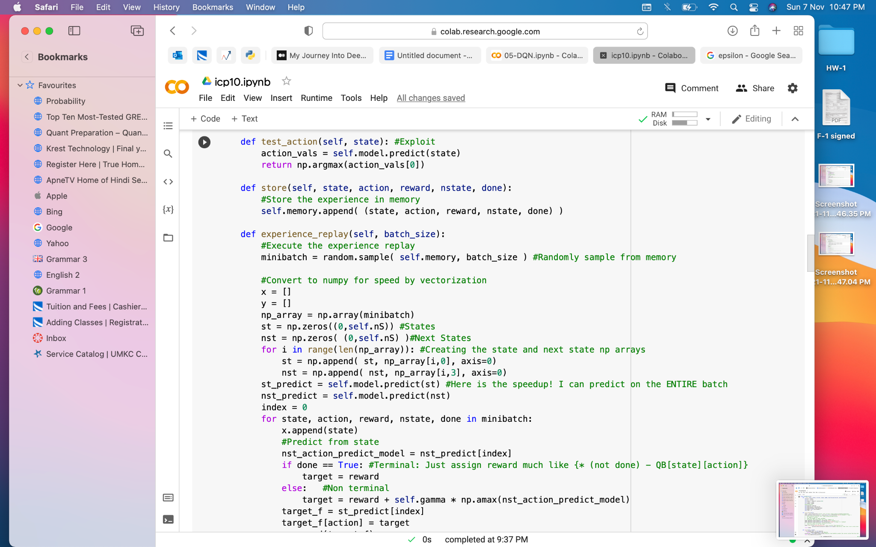

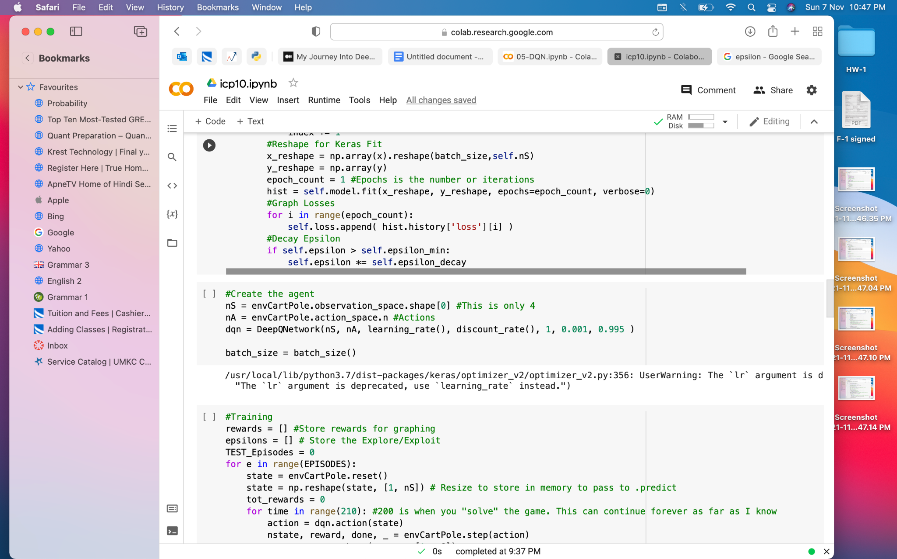

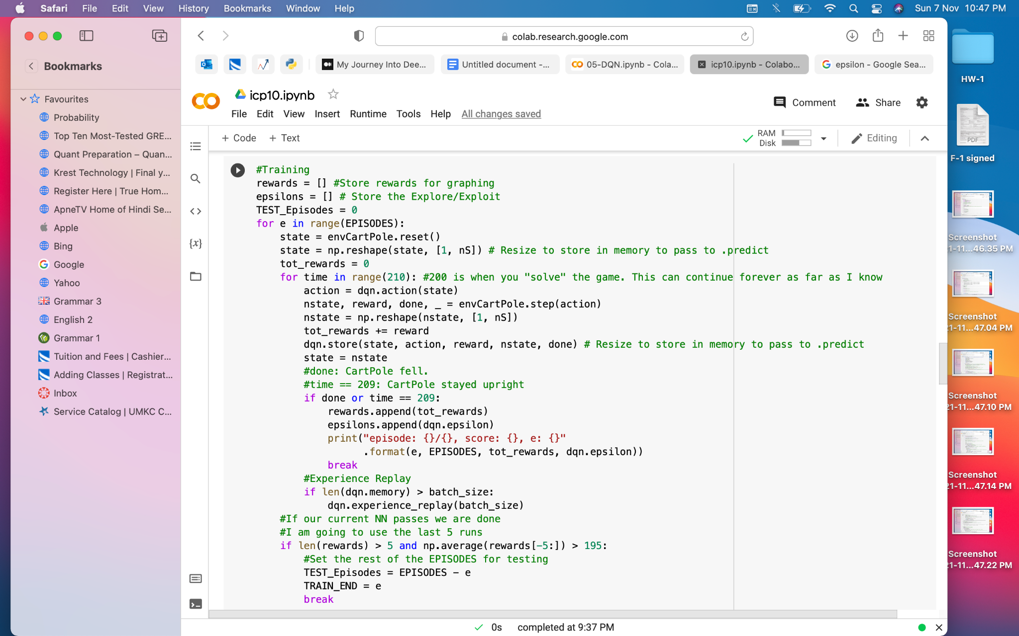

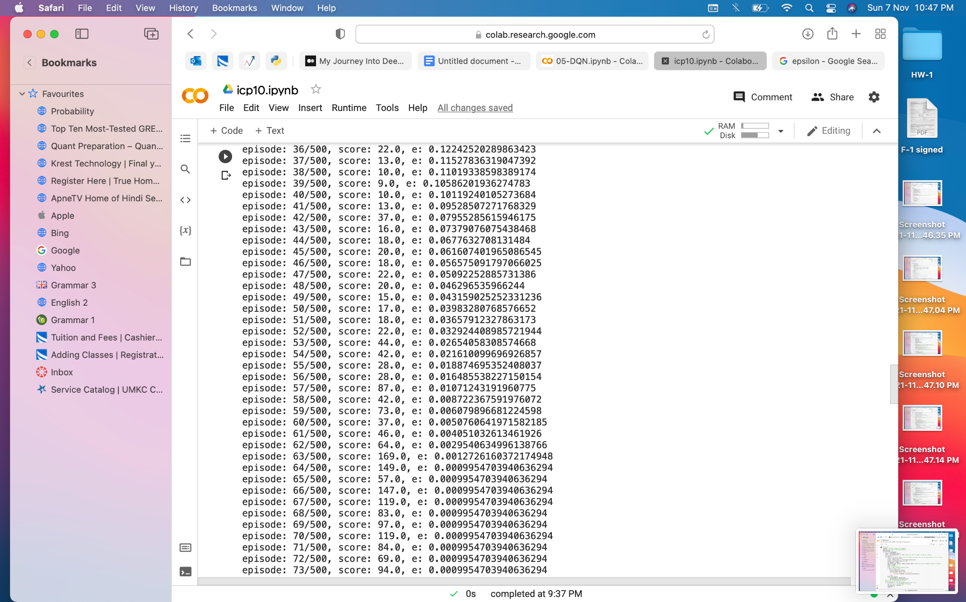



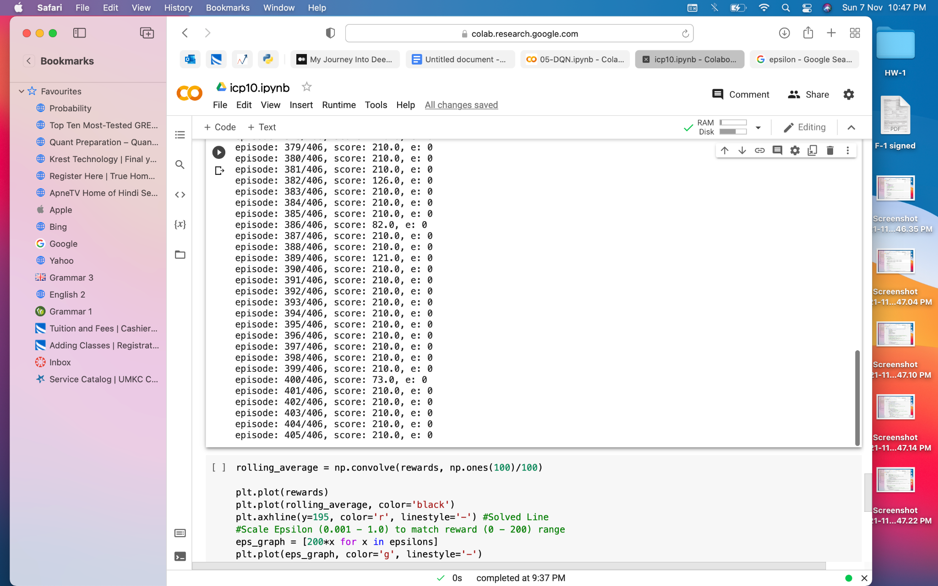



**E)VideoLink:**[**https://github.com/UMKC-APL-BigDataAnalytics/icp-10-assignment-10-saidurga-kanuganti/blob/main/Mon%20Nov%2008%202021%2009_11_09.webm**](https://github.com/UMKC-APL-BigDataAnalytics/icp-10-assignment-10-saidurga-kanuganti/blob/main/Mon%20Nov%2008%202021%2009_11_09.webm)

**G)**Implementing Deep Q Learning in Python using Keras & OpenAI Gym. In deep Q learning, we use a neural network to approximate the Q-value function. The state is given as the input and the Q-value of all possible actions is generated as the output.